Setting Up Label Studio For Active Learning!
C:\Users\aware\Desktop\label_studio_projects
Step 1: Set Up Your Virtual Environment and Label Studio
Configure a virtual environment and install Label-studio as directed on the Label-Studio website
Within the virtual environment, apply these 2 settings:
> set LABEL_STUDIO_LOCAL_FILES_SERVING_ENABLED=true
> set LABEL_STUDIO_LOCAL_FILES_DOCUMENT_ROOT=C:\\users\\aware\\desktop\\label_studio_projects
Note: Be sure to use your own C:\\ path where you will store images. Later, you can specify subfolders under this path for a specific project.
To start the program:
> label-studio start

Step 2: Configure Local Storage
Create a new project in Label-studio and determine your labeling interface.
To set up your local storage:
a. Go to your Project and then Settings (box in upper right)
b. Go to Cloud Storage.
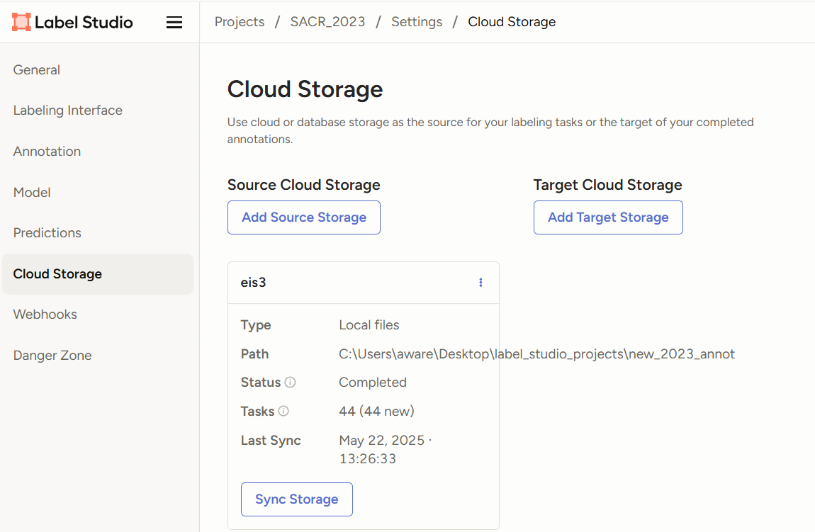

c. Click Add Source Storage
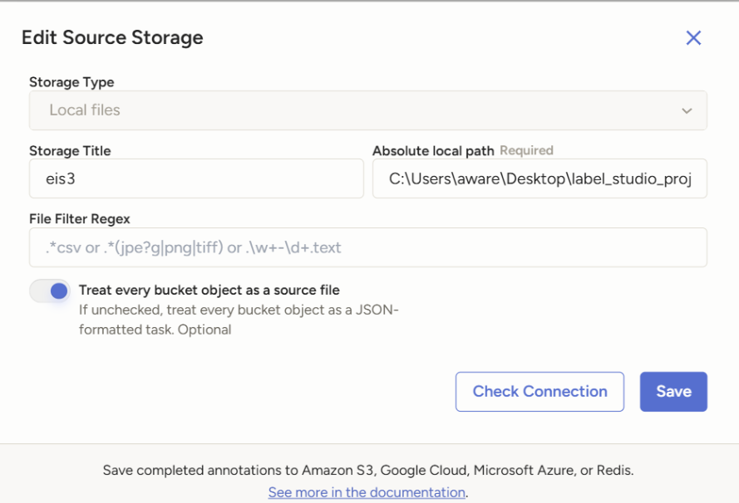

d. Select Local files from the Storage Type options.
e. Give this directory a Storage Title
f. Set the Absolute local path. For Windows, set it to:
c:\users\aware\desktop\label_studio_projects\new_annotations
[this must include your environment path set in Step 1 above, as a starting point, but can include subfolders]
g. Check the box for Treat every bucket object as a source file
h. Check the connection and save if it is successful.
i. After the storage is connected, you may need to come back and click sync, only if needed.

Step 3: Convert your annotations to Label-studio json format
Under AI-for-USFWS-Migratory-Birds > Convert CSV to Label Studio json 2025.py
This script converts your csv annotations to COCO, then into Label-studio json using Pycharm/Python
In your Label-studio project > Import > add your newly created Label-studio json. If everything is correct, your images with show up with their annotation prediction boxes.
"/data/local-files/?d=SACR_2025_annot_tiles%5
Above, SACR_2025_annot_tiles is directory under the local source directory
If annotations do not show up:
- Import > add your images directly here
- To the right of your images (as below), click the </>
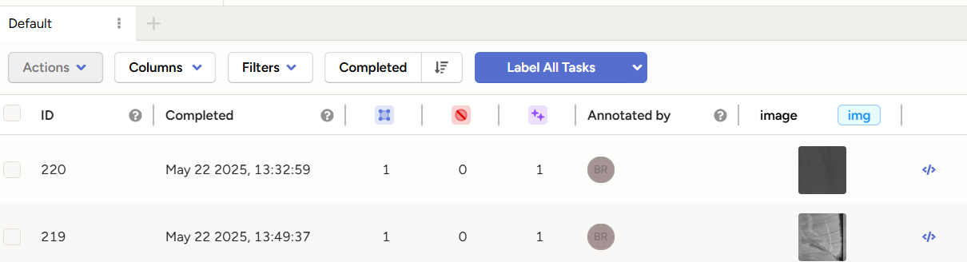

The following is displayed:
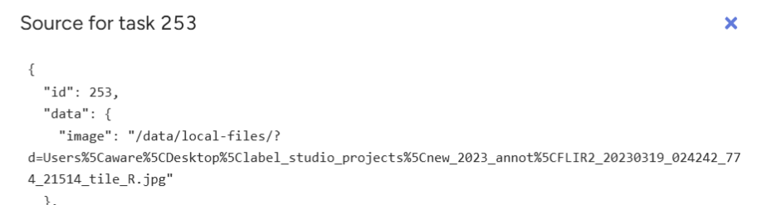
From this information, you can see the image path. Above the path is:
/data/local-files/?d=Users…
Open the Label-studio json in a text editor
Use the Find and replace function to change the directory to what you see in Label-studio (as above),
This fixes the path. You will need to delete all existing tasks. Then, go back and import your Label-studio json file. Importing this file will be bring up the images in your local storage along with the annotations.

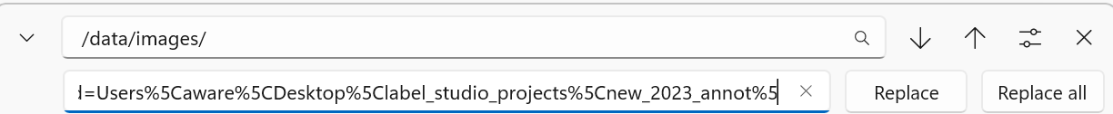

4. Import predictions to existing tasks
In some cases, you may want to apply predictions to already imported tasks. For example, you can retrieve tasks from Label Studio, then create a new prediction:
In [1]:
from label_studio_sdk.label_interface.objects import PredictionValue

li = ls.projects.get(id=project.id).get_label_interface()

for task in ls.tasks.list(project=project.id, include=['id']):
prediction = PredictionValue(
# Tag predictions with specific model version
model_version='my_model_v1',
# Define your labels here
result=[
li.get_control('image_class').label(['Dog']),
]
)
ls.predictions.create(task=task.id, **prediction.model_dump())

